POS PROJECT SETUP

- Inside the D Folder create a “pos workspace” folder

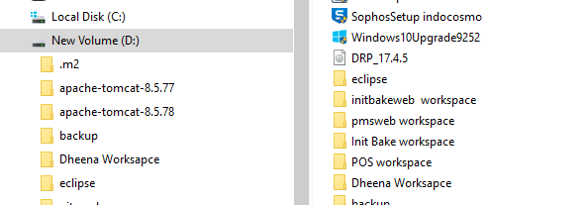

- Add “posella-server” & “posella-terminal” inside that folder

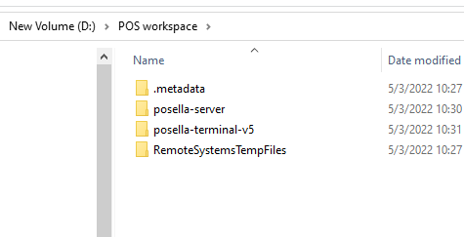

- Launch Eclipse with “pos workspace”

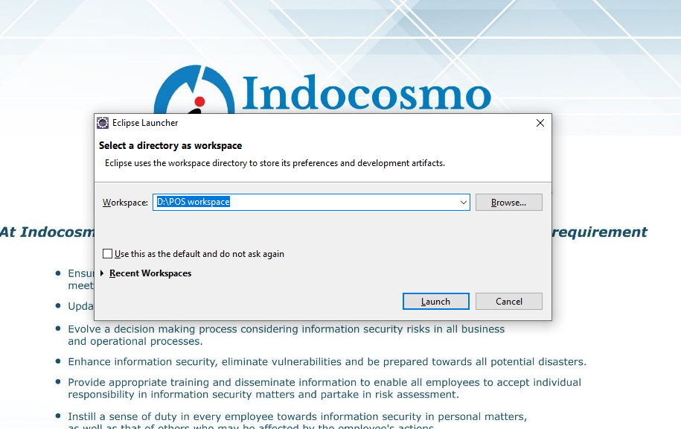

- Import posella -server and posella terminal using
file---->import---->file location--->finish

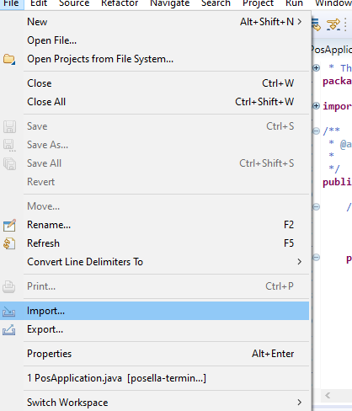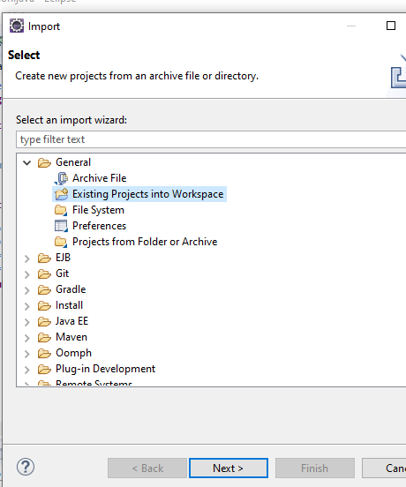

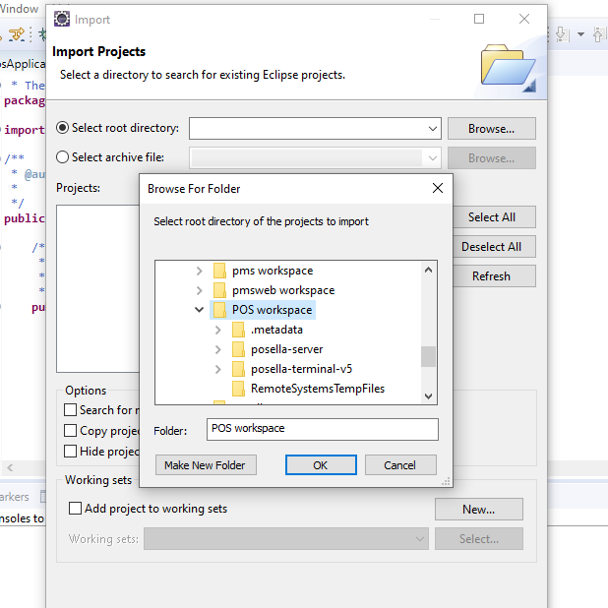

Browse the file location and then OK

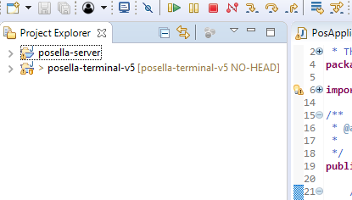

- For run the project

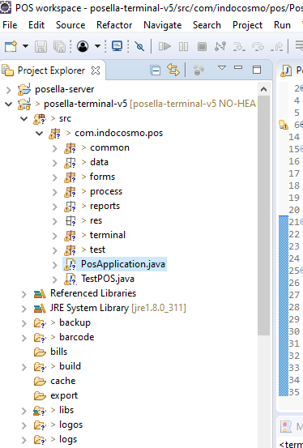

Right click on the “PosApplication.java” then Run as a java application.

Then give the output like follows

